**A simple screen grid current monitor for the NCL2000.**

Over the years I’ve had more than one Tetrode go “up in smoke” due to operator error, and since self-training has proven to be a lost cause, I decided to look at possibly preventing future occurrences electronically.

My goal here was to adapt the essence of the G3SEK design into my National linear amp. If you have a commercially built linear, the screen supply parameters have already been evaluated and deemed adequate for service under most any field conditions, so more massaging, to me, didn’t seem appropriate. That said, I set about finding the simplest way to accomplish the task.

Once detected, over current conditions should result in latched, resettable B+ power supply shut down as quickly as possible, and to that end, most any linear has some sort of cabinet entry shut down circuitry to do just that, so I saw no reason to reinvent the wheel.

What I present here takes advantage of as much of the original amplifier design as possible, and simply added that necessary to accomplish the original goal, of shutting B+ down ASAP.

The detector is simply an opto coupler. A screen grid over current condition can occur with the screen grid going either above or below the screen supply output voltage, therefore to maintain proper polarity, it must be driven by the output of a diode bridge. The Screen grid current limit, AKA the opto turn on threshold, is set by selecting the resistor in parallel with the opto coupler input, as shown in Figure 1. You can establish this by using an adjustable low Volt DC supply.



Once shut down, the condition must be latched, and the easiest way to accomplish that is to use a small, DC, low drive current DPDT relay. The opto coupler isn’t capable of enough drive current to operate any relay so I used a simple Emitter follower, and in the latching feedback path I put a momentary Normally Closed push button switch contact. I also mounted a high output LED on the front panel next to the switch. The second set of relay contacts were arranged to activate the existing cabinet safety circuitry, as in figure 2.

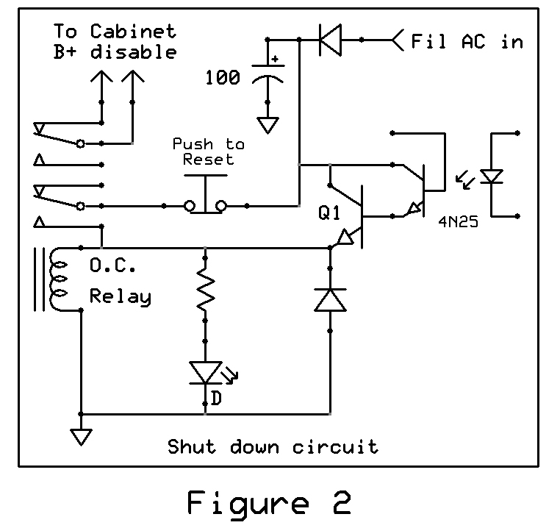

I know relays seem old fashioned, but because they are simply “contacts”, there are no worries about AC, DC, Current, or Voltage precautions, AND its simple.

Many amplifiers utilize two tubes in parallel, and there are a couple ways to accommodate this. One is to just add a few more diodes to the mix as shown in figure 3. Another approach is to use a second bridge and associated opto coupler, OR’ing their outputs to drive the Emitter follower / relay driver as shown in figure 4. Either way will work, but be sure to remember the current limiting resistor for each tube must be across the output of that tube’s associated diode bridge.

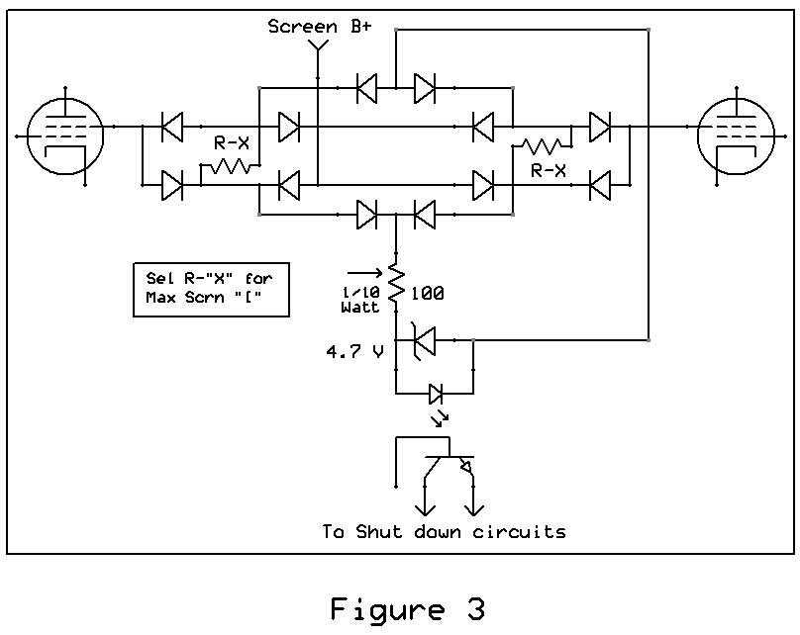

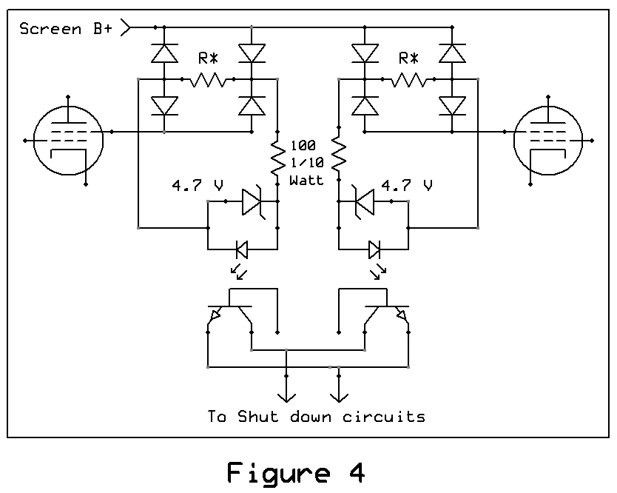

PA tube maximum screen currents, available low voltage sources, cabinet B+ shut down circuitry, etcetera are different for each manufacturer’s amplifier model, so some investigation will be needed, but this simple project is a good exercise in some basic design effort.

Implementation

In addition to the current limiting, I wanted to install a second PA bias source to allow greater latitude in tubes that can be run together in parallel operation. This meant that a second adjust pot and test point needed to be installed on the rear apron.

There isn’t a lot of spare room in the National cabinet for extras, so I decided to remove the existing bias circuitry and a little re-do of the screen supply. The original screen supply electrolytic filter cap is at bottom right.

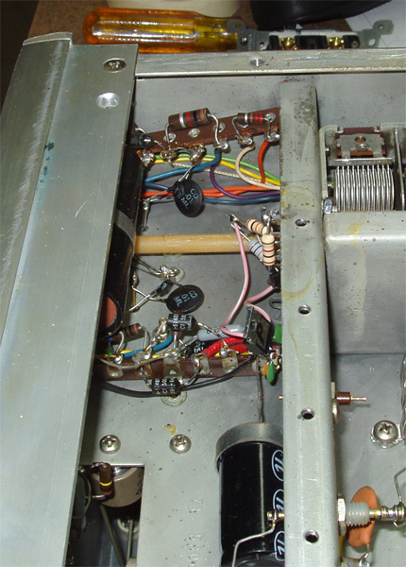

So a few parts were removed to make room for the new circuitry. The electrolytic on the left is the new location for the screen B+ cap.

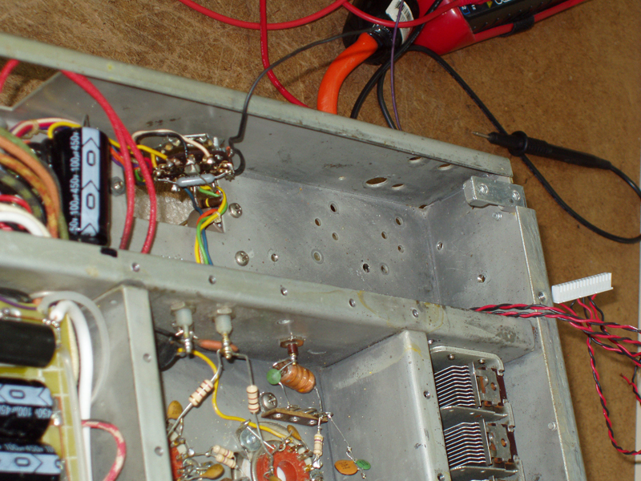

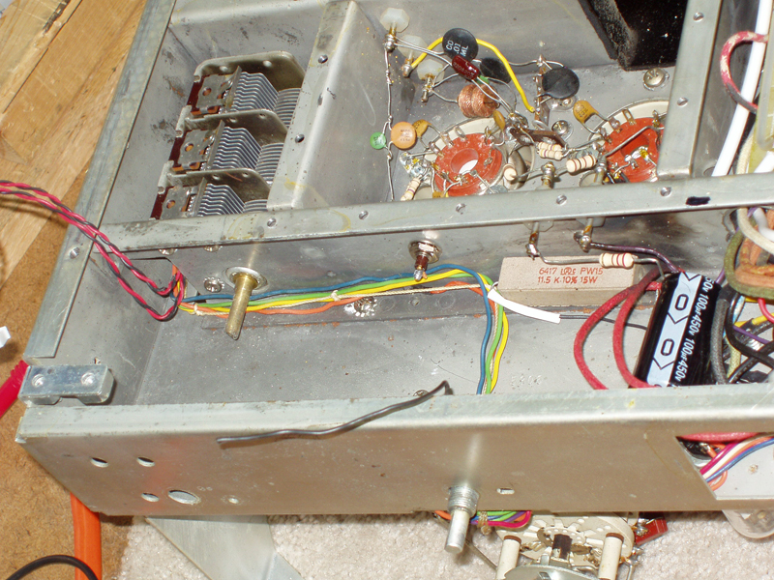

Everything else was removed with the hope it’ll all fit on the new piece of Vector board, and the existing wires were rerouted to the rear wall of the compartment. No PCBs here, I’m still not sure I want to start that whole process.

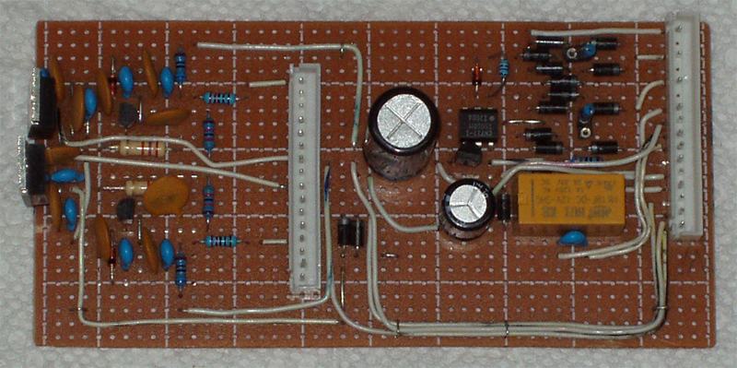

I was pleasantly surprised all the components fit with considerable room to spare. I use connectors simply because rework is inevitable.

The PCB assembly’s first fitting into the compartment. The Loading capacitor shaft will just clear the top surface of the board with 1/4” spacers. I determined the locations for the mounting holes and the transistor tabs. I use mica and aluminum oxide to mount devices. There may be other methods out there but this has worked for 40+ years and I’m stickin with it.

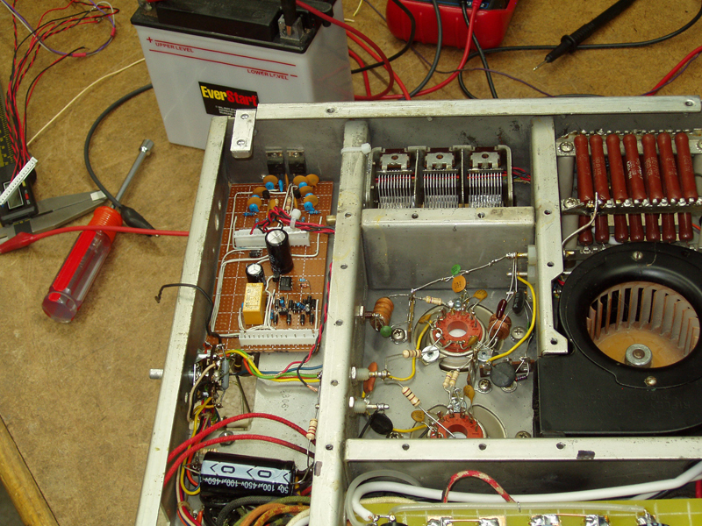

I used a variable bench supply to set the screen grid current tripping points, and also verified the operation of the bias supplies. Once done, the board was installed in the amplifier. The wiring was verified then I proceeded to testing.

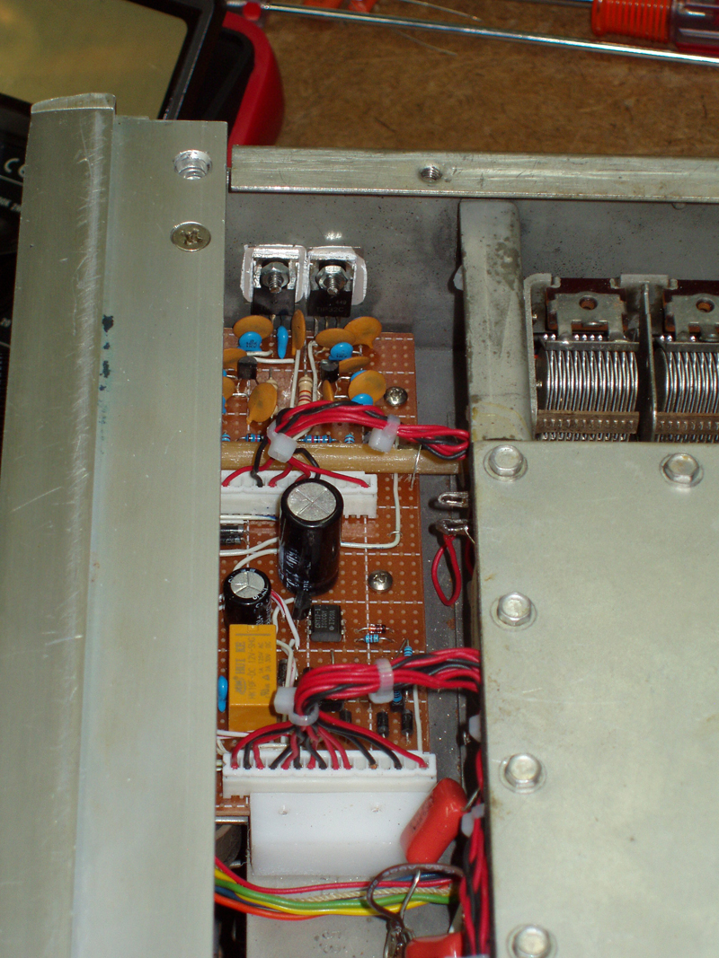

Note the Load capacitor shaft running across the PCB. The white plastic block is at the bottom of the board because there was no allowance made for mounting screws early on, not good.

Testing proceeded without a problem and the final test was to disconnect the anode B+ and attempt to activate the amplifier. This was done 5 times, in fairly rapid succession, anode voltage was then reconnected, B+ applied and Idle current and amplifier output were verified. No significant change, all was good. These weren’t “good” tubes, but after the above sudden death test, I’m pretty confident the good tubes are safe. The reaction time from application of B+ to the over current monitoring circuit’s removal of same was measured at 7 milliseconds.

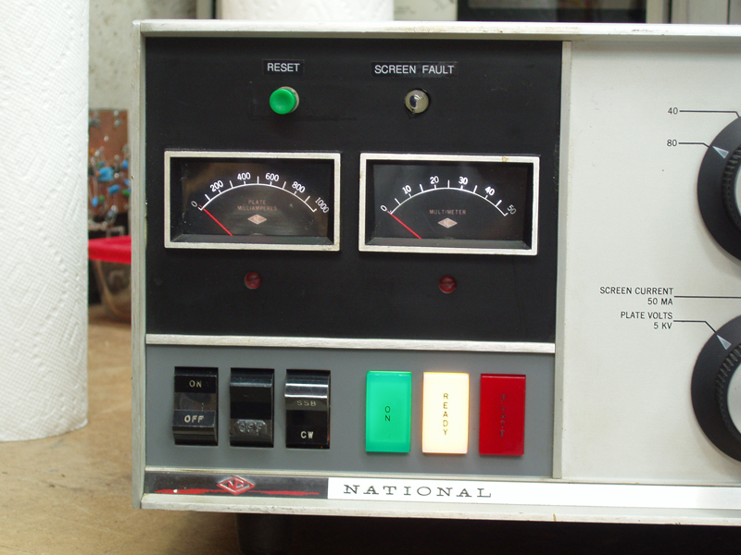

I used the original National medallion mounting hole locations for mounting the switch and LED indicator.

I’m satisfied with the performance so far, but time will tell if it works well under all conditions.

Mike Harrison

KE0ZU