My “New” Henry Amplifier 2KD-3 circa 1970
By Mike Towers N5RXP
A few years ago I was tooling around Austin, Texas and happened to drive by a garage sale in a nicer part of town and saw a bunch of radio and electronic stuff. Sure enough, the guy had a Henry 2KD-3 RF amplifier for sale. I won’t say what I paid for it, but I sure as hell bought it on the spot.
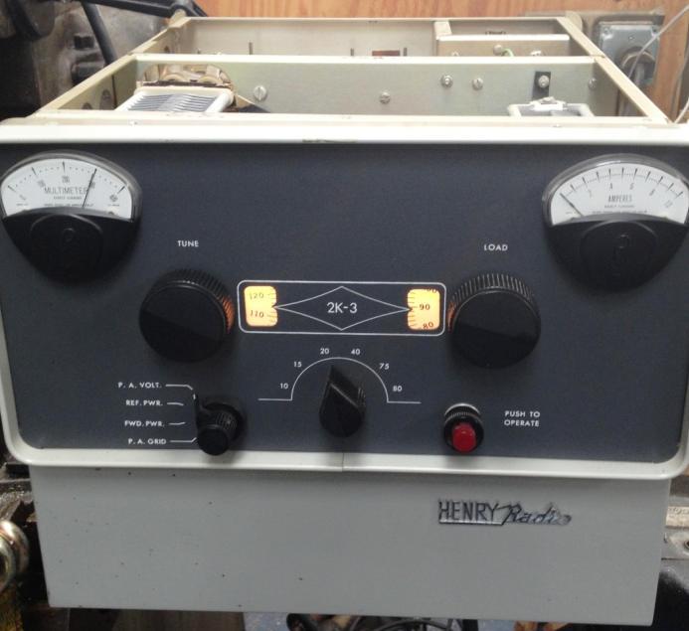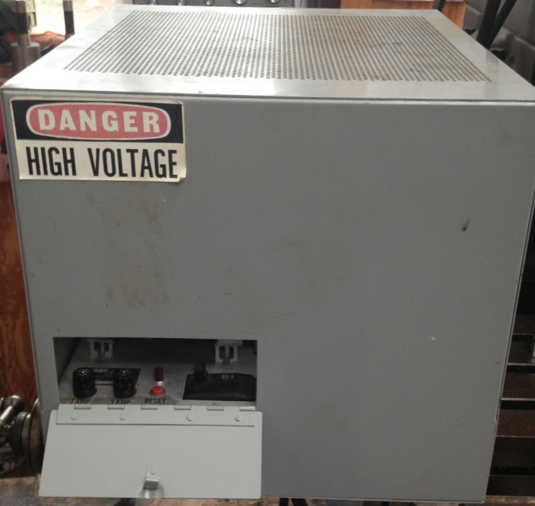
The Henry Amp came in two large boxes: one a perforated gray metal box with a power cable and data cable coming out of it and one in a mysterious gray abs plastic shipping container. The former was the power supply (VERY heavy) and the latter the RF deck, all packed away nicely.

I was working then and took it home and stored it and forgot about it. Then, I retired a couple of years ago and decided to get back into Ham Radio. I dug out my old FT-101e from the mid-eighties, dusted it off, hooked it up to a Cushcraft vertical, and it fired right up. Unfortunately, it became obvious to me that if I was going to “get out” from the Texas Hill Country, I was going to need some more power.
Then I remembered my old Henry amp. I started doing some research and discovered it was really a venerable old collector’s piece, much like a 57 Chevy. So, I decided then and there to put together a retro, all tube shack, featuring my FT-101 and my Henry.
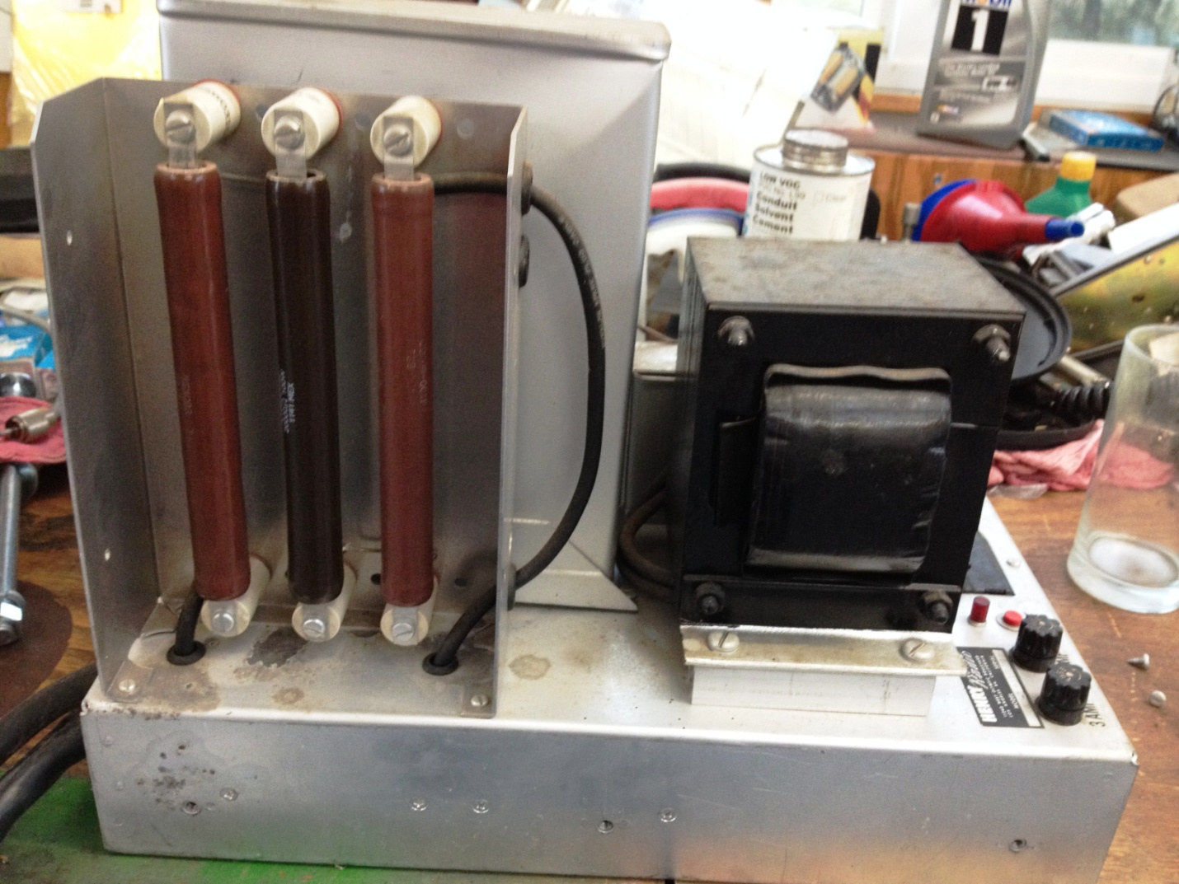
I opened up the Henry to inspect it, and much to my delight it appeared to be intact and relatively clean…..at least the RF deck was. Then I opened up the HV box, and the middle HV bleeder resister was broken in three places…not good. With a little advice from NE7X I replaced the resistor and then inspected the four HV diodes that comprise the full wave bridge rectifier for the B+ supply. One of the diodes was broken at the mounting ear. This indicated to me that there might have been an over-temperature condition on the diode/bleed resistor circuit. So, I decided to replace the diodes, too.
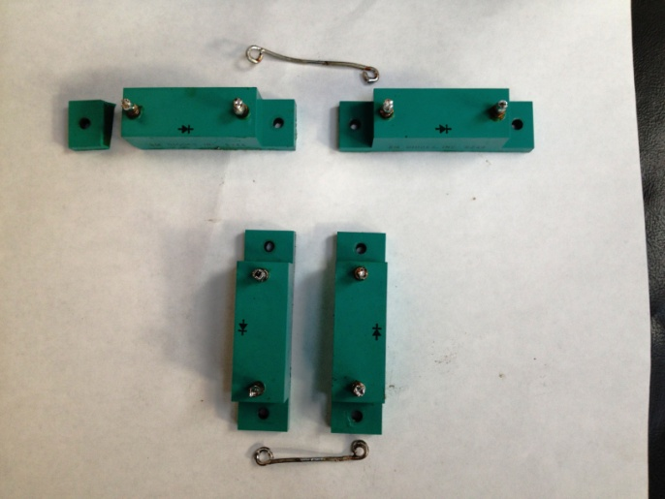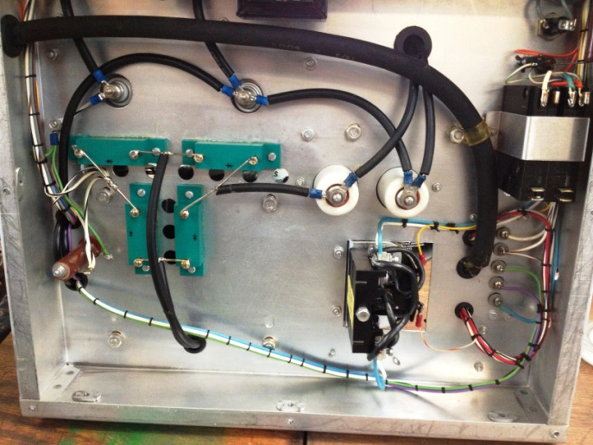

Then I discovered that the manufacturer does not recommend using these diodes anymore. Fortunately, Mr. Ted S. Henry has a Henry Radio upgrade to the OEM parts. Ted’s diodes come two to a package, so the form factor is slightly different. And, like all Henry Radio stuff, they are first quality…with a price to match.
However, after conferring with Ted Henry about the complexity of performing the upgrade, I decided the quality parts AND the expert support were worth a few extra bucks over the Hong Kong variety. So, I sent Ted some money.
The diodes arrived timely, a few days later, very well packed for shipment. Ted was even thoughtful/professional enough to include a small tube of heat conductive paste to mount the diodes with. Thanks Ted.
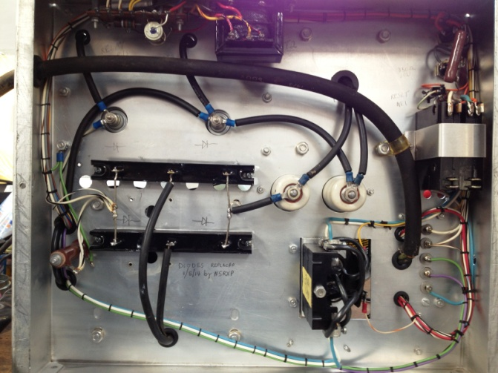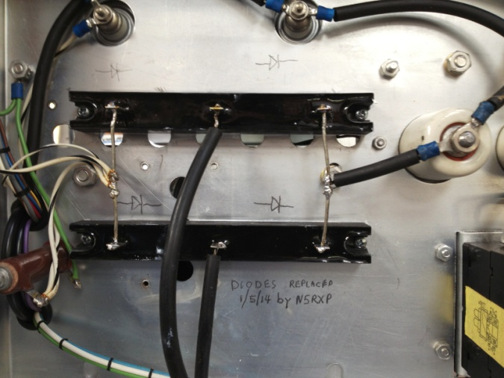
I went to install them, and then discovered I was going to need to drill a couple of holes because the form factor was different—remember, what was FOUR discrete diodes was now two diodes in only TWO packages. I laid out the parts carefully, being mindful of interference with other components on both the top and bottom of the HV deck chassis. I then discovered that the OEM screws were about ¼ inch too short…….so off to the hardware store for the only screw size I don’t have.
I soon got the new diodes located, drilled, and mounted, along with a liberal coating of thermal paste. And, I hooked up the high voltage and relay leads with no problem, actually using two fewer jumper wires than the OEM….a clean upgrade.
BTW: Fred KC5RT is also a Henry freak, and has some really good tips on his website about Henry amps. I used a couple of them right away…….Thanks Fred.
I put the amp all together, the HV supply all together, the discovered that the HV supply power cord is for 30 amp 220 like for a room air conditioner and my combination shack/shop is wired for 50 amp 220, like for a welder. That makes for plenty of compatible power, but incompatible plugs/sockets. So, back to the hardware store for the only power plug/socket I don’t have.
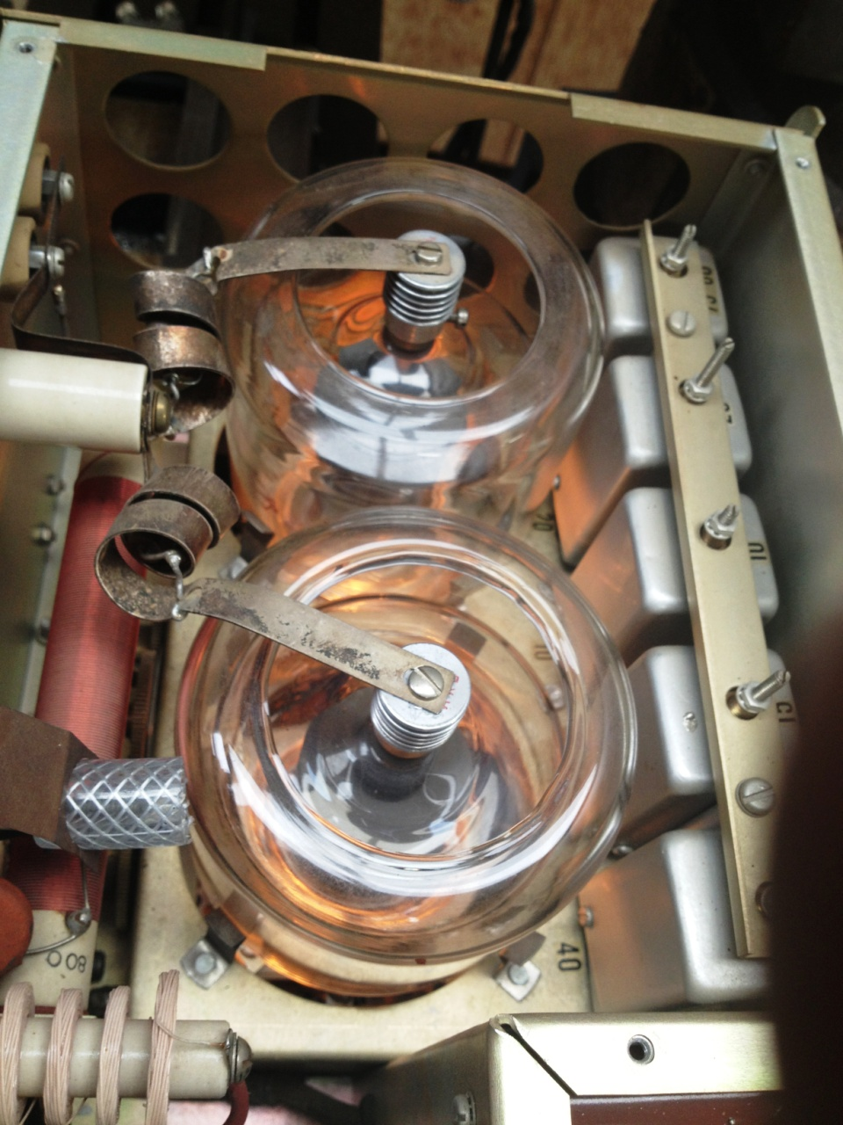
Today I hooked up all the proper power to my Fox Tango so I would have proper termination at all the ins & outs, and did the smoke test on the Henry. I was a delight to hear the big jet engine whine of the blower fan, and then see the beautiful glow of those two gorgeous 3-500zs.
When I get all the wires and cables dressed a little bit, I will actually tune it up and put some RF to my Cushcraft vertical. I full well expect to see birds fall from the sky and flames emit from the radiators!!!
73 de Mike N5RXP

